|  |  |
| --- | --- |
|  |  |
| ICIN Bank ScreenShots |  |
|  |  |
|  | Sameer Safdar Khan |
|  |  |

**Project Name: ICIN Bank**

**Document Type: Screenshots**

Submitted By: Sameer Safdar Khan

GitHub Repository: <https://github.com/SameerKhan0411/ICIN_Bank.git>

Admin Portal:

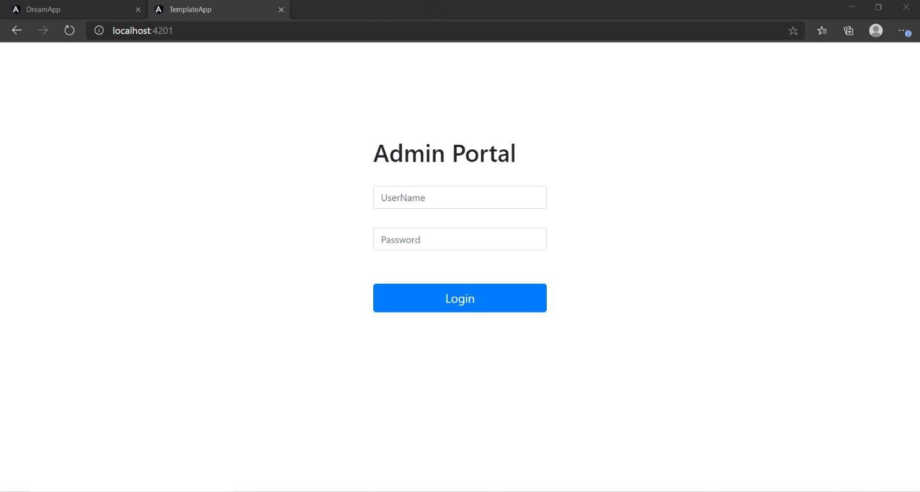

Admin user database

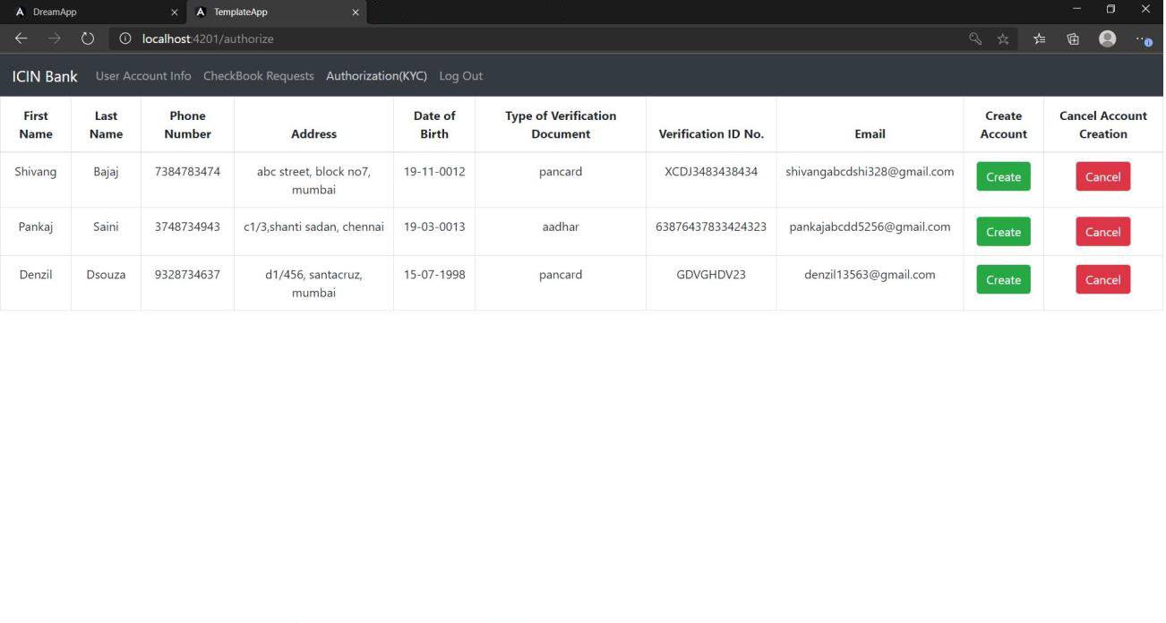

Admin User Account Control

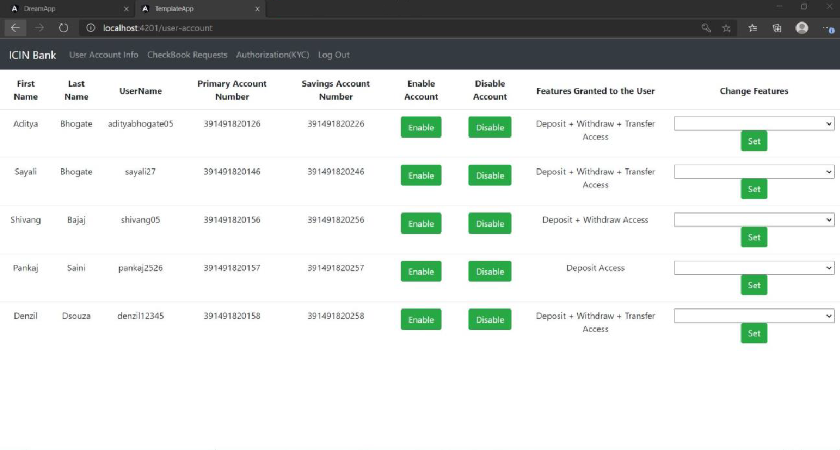

Admin Check Book Issuing

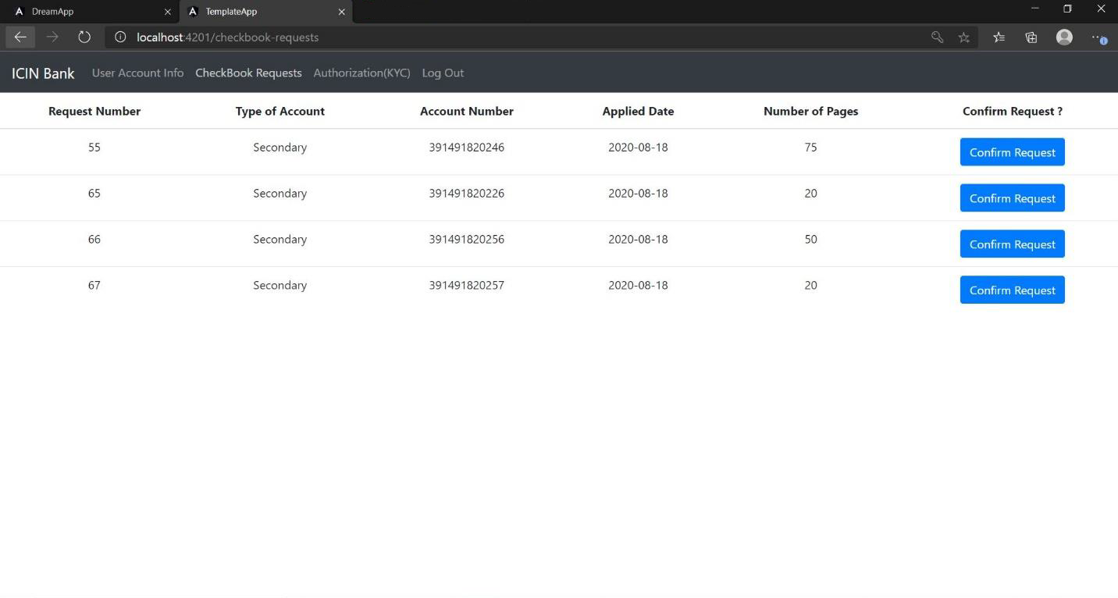

User registration

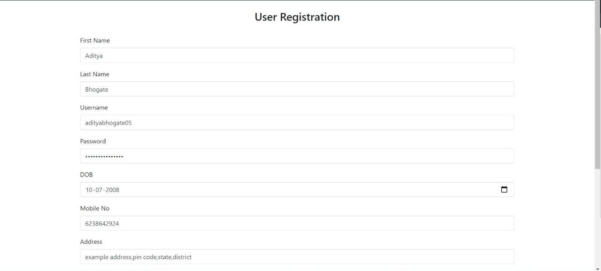

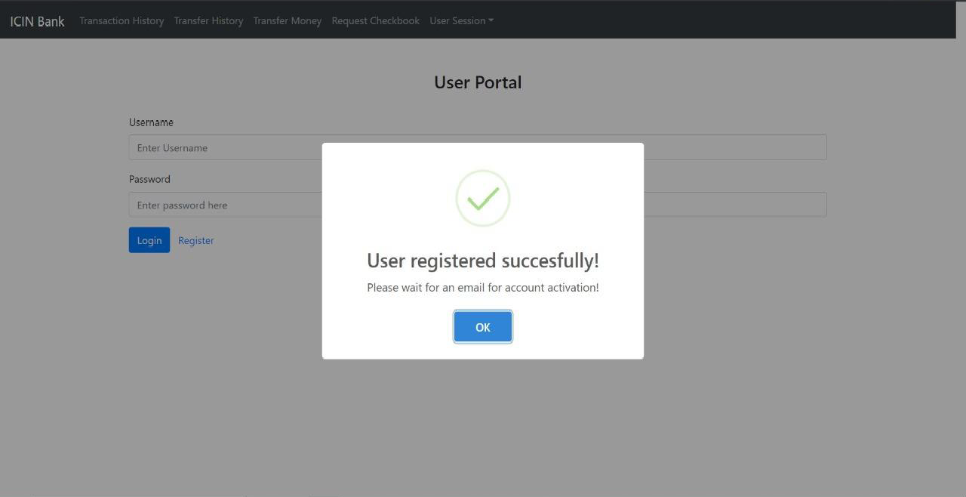

User Login

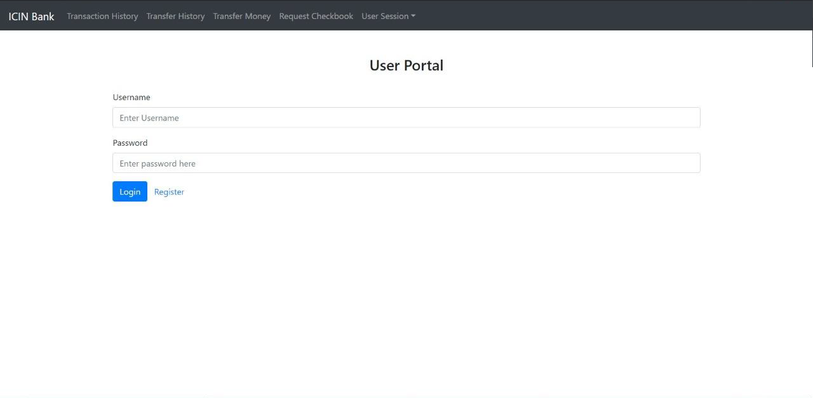

User Welcome

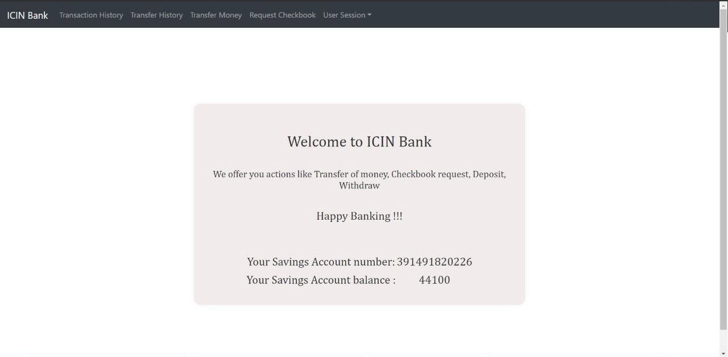

Transfer money

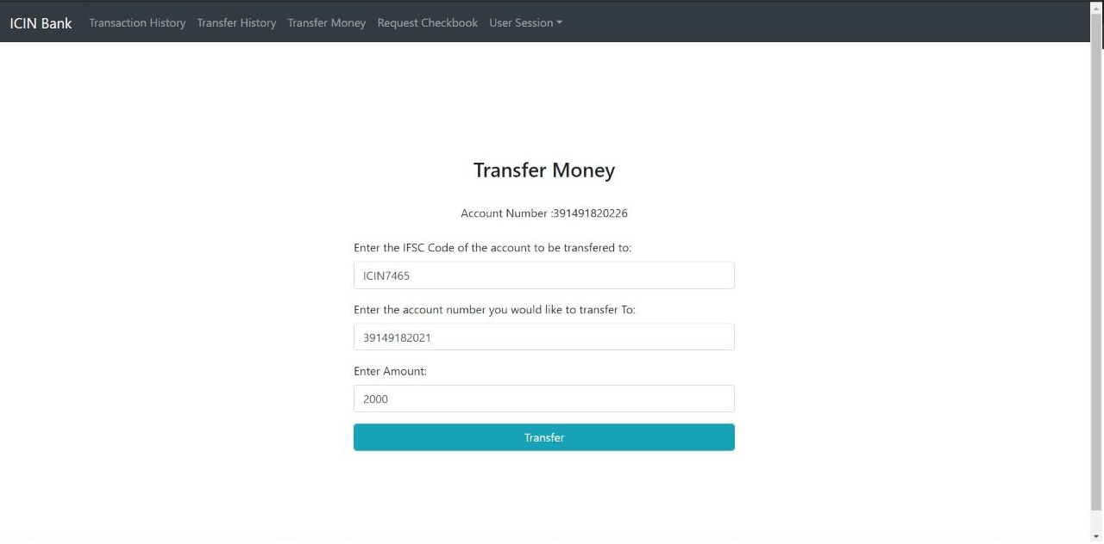

Request Check Book

